DAWSON MINE

SPECIFICATION

Small portable generators

<25kVA

Document Control
Rev No | Date | Revision Details |  | Originator | Checked | Discipline  Lead | Engineering  Manager
0 | 18/06/19 | Initial Draft |  | DA

Purpose

The purpose of this document is to introduce a specification to assist in sourcing a suitable portable generator for small load applications on Dawson mine site. This specification guide is limited to generators up to 25kW in supply load and is intended for use in stand alone application. The generator set may be portable, semi-portable, transportable or mobile.

Relevant Laws, Regulations and Standards

In addition to set requirements within this specification the following statutory rules and regulations, and Australian Standards must be followed including but not limited to:
- Coal Mining Safety and Health Act 1999
- Coal Mining Safety and Health Regulation 2017
- Work Health and Safety Regulation 2011
- Electrical Safety Act 2002
- Electrical Safety Regulations 2013
- AS 3000:2018 Wiring Rules
- AS 3008:2017: Electrical Installations – Selection of Cables
- AS 3010:2014: Electrical Installations – Generating Sets
- AS 3007:2013 Electrical equipment in mines and quarries – Surface Installations and associated processing plant
- AS 2081:2011 Electrical protection devices for mines and quarries
In the event where this specification contradicts with a law, regulation or standard’s condition or recommendation, then the relevant law or standard shall be complied with.
All installation, testing and commissioning of electrical equipment must be carried out site authorized personnel. The following procedures and standards apply:
- PHMP 0015 Control of Energy
- SOP 0001 Access to Exposed Electrical Conductors,
- SOP 0004 Electrical First Aid and Resuscitation
- SOP 0034 Live Testing of Equipment

Definitions

In addition to all defined terms in MOP 0123 Electrical Definitions the following applies:

RCD | AS 3190 approved Residual Current Device
CB | Circuit breaker
LV | Refers to electrical circuitry or system that is higher than ELV but lower than 1200VAC
ELV | Refers to electrical circuitry or system that the voltage does not exceed 50VAC or 120VDC
ELD | Earth Leakage Device
PHMP | Principle Hazard Management Plan
SOP | Standard Operating Procedure
Shall | Indicates the statement is mandatory to be complied with
Should | Indicates the statement is a recommendation
Owner | The person who intends to introduce an equipment to site or sources it
DOL | Direct On Line type of motor starting
Load/ Load Type | Rated power usage of an electrical equipment and type of an electrical equipment

Pre-requisite to sourcing a generator
Suitability of any generator and sizing of it will primarily depend on its application. For instance, high inductive loads such as DOL Induction motors would require the supply to compensate against adverse effects of low power factor. The owner of the portable generator must define the intended usage of the generator, including the total anticipated loading and type of load. This information must be provided to the generator supplier. Refer to Appendix XXXX for a complete list of information that should be conveyed to supplier during enquiry and order. The generator sourced must meet or exceed AS 3010:2017 requirements.
In addition, the following questionnaire should be completed and relayed to site EEM as a pre-requisite with intention to source a portable small generator.
Intention to source a portable small generator
- Owner details
  - Name:
  - Department:
  - Contractor:
- What is the intended usage for the generator? i.e Emergency back-up, standalone
- What type(s) of load will be applied? i.e. refrigerators, pumps, fans etc.
- Intended operating periods?
  - Maximum continuous usage
  - Number of hours per day/week
- Would the generator feed a switchboard;
  - With mains supply?
  - Without mains supply?
- How many plugged outlets will be required?
- What type of fuel will be used?
- What is the requirement on;
  - Voltage?
  - Phases?
- Where would the generator be stationed and operated at?
  - Outdoor/ Indoor?
  - Provide details
- Has the datasheet for the generator obtained? Provide a copy.
- Has the owner revised ‘Small portable generator specification’ and understanding its requirements fully?

The EEM will review this information and provide any recommendations that may be of relevance.

Introduction to site
The introduction to site process specified here would encompass a strategized method for Purchasing/Sourcing, Installation and commissioning of a portable small generator (<25kW). The process is summarized as checklist form in Appendix XXX. Following successful installation and testing, the EEM will review completed documentation, and upon satisfaction of meeting site standards will provide Authority to Energize.

Purchase/Source of a portable small generator
After Pre-approval to source a generator has been obtained by EEM, the owner may source a generator from a suitable supplier provided the generator model, type, and design meets relevant standards and regulations, particularly AS 3010:2017 and AS 3100:2017. The onus is on the owner to ensure sourced generator will meet site and regulatory requirements. It is recommended the owner reviews rest of this specification prior to purchase and gain a comprehensive understanding of installation, protection and safety requirements of the generator.

Installation and Commissioning on site
All installations onsite must be carried out by a competent and authorized electrician in accordance with relevant Australian Standards. Focus should be given to:
- AS3000:2018 Wiring Rules
- AS3008:2017: Electrical Installations – Selection of Cables
- AS3010:2014: Electrical Installations – Generating Sets
- AS3007: Electrical equipment in mines and quarries – Surface Installations and associated processing plant
Furthermore, a risk-based approach must be adopted during installation and follow relevant site procedures and standards including;
- PHMP 0015 Control of Energy
- SOP 0001 Access to Exposed Electrical Conductors,
- SOP 0004 Electrical First Aid and Resuscitation
- SOP 0034 Live Testing of Equipment
The installation and commissioning checklist of small transportable generator will cover the following.

Service Conditions
The generator should be rated for ambient temperatures for minimum of -15ºC and maximum of 40^{O}C
The owner should define the area of operation for the generator with either
- Undercover or weather protected usage
- Outdoor usage where IP54 must be maintained for all electrical enclosures and live parts, with no exposed electrical conductors.
When used undercover or in a housed area considerable precaution must be taken to manage exhaust fumes that may pose as a potential asphyxiation risk.
Generator electrical output shall have maximum allowed voltages as per phase design:
- Phase to neutral 230VAC
- Phase to phase 460VAC
- Center tapped (180º phase to phase) 230VAC
Additionally, an ELV circuit is allowed for battery charging purposes.

Electrical installation and protection

Cabling and live parts
All exposed cables shall be identified as per AS 3100, and all cables that are connected to the frame must be considered as earthing cables. All cable installations must comply with AS3000:2018 Wiring Rules. Attention should be given to wires that may undergo mechanical impact such as pull, twist or pinch motions during normal operation or maintenance. Cables that may be exposed to such adverse effects should be either armored, in conduit or protected by equivalent mechanical protection.
Where low voltage and extra low voltage circuits are available such as battery charging ELV cables, they must be separated by double insulation from LV circuits.
There shall not be any exposed live parts including the neutral that may directly or indirectly allow contact with personnel or the generator frame. Adequate guarding shall be provided for such live parts, with consideration given to ensure that the guarding will not in-advertently contact live parts.
All covers or guarding that may expose a person to live part must require a special tool to open and expose the live parts.

Joints and connections
All joints and connections shall have adequate strength to withstand mechanical pull, twist, and vibration during normal operation or standard maintenance. They shall be in good condition such that a failure is unlikely during in its foreseeable machine operation.
Where there are busbar joints, they shall be tin or silver-plated, and shall be bolted to assembly. The bus bars shall be air insulated and there shall be no other equipment within the bus bar zone. The bus bar shall be colour coded for an anti-clockwise phase rotation system (for a three-phase supply).
Where there is a separate cable termination enclosure, the enclosure must be rated IP55 for outdoor use. Cable entry shall be glanded with plated bolts, nuts and spring washers. The cable glands must accommodate next largest cable size that is rated above the generator rated current.

Earthing and bonding
All exposed metal parts shall have means of earthing. They shall be in good electrical contact with each other with a common earthing facility that is used for effective earthing. Earthing connection on frame must be clearly marked for identification.
Equipotential bonding must be effective on each other of the following:
- The engine frame.
- The generator frame.
- All external metal enclosing electrical equipment or wiring.
- The ‘earth’ terminals of all socket outlets.
- The main frame.
- The main winding, as specified in section 5.2.2.5.
- The ‘earth’ connection of any electronic circuitry that may need to be connected to above items.
Resistance between any metal part to the earthing facility must not exceed $1Ω$. All earthing and bonding cables must not exceed resistance of $0.1Ω$.
All earthing cable sizes must be in accordance of Clause 5.3.3.1.3, AS 3000:2007 Wiring Rules except that minimum earthing cable size shall be 6mm² copper PVC covered green & yellow earthing cable.

Outlet overload protection
Overload protection should be in the form of circuit breakers in accordance with AS 60898 except where authorization is given by EEMs on his own discretion for usage of Fuses and/or electronic module devices (stable voltage and frequency governance) for generators up to 15kW where used in certain restricted applications.
The circuit breakers shall be accessible without a special tool. Breaking capacity of CBs shall be able to withstand full fault current of the supply. Pickup values and time setting shall be adequate to protect any outgoing supplies by OEM recommendation, power study or the chosen CBs shall be able to provide overcurrent protection to any outlet and/or cables.

Winding connections
- Single-Phase (RCD protected)
The outlets shall be 30mA RCD protected. Refer to diagram below
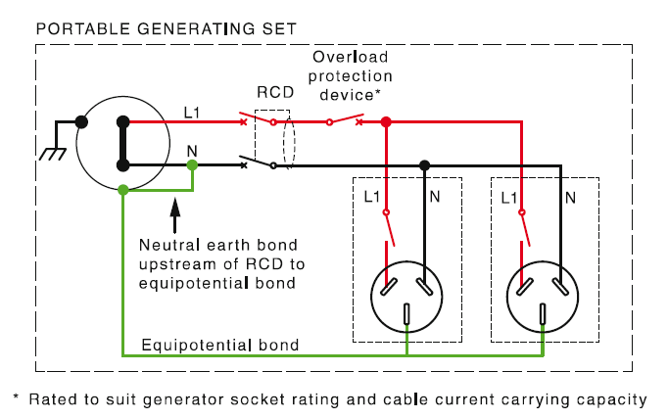
Figure 1:AS 3010:2017 Figure B4 RCD protected outlets
- Three Phase (Isolated)
There shall be no connection between the frame and the neutral point of the windings.
The 3 phase+N+E connection shall be connected to main switchboard with MEN. The main switchboard shall appropriate earth fault and overload protection.
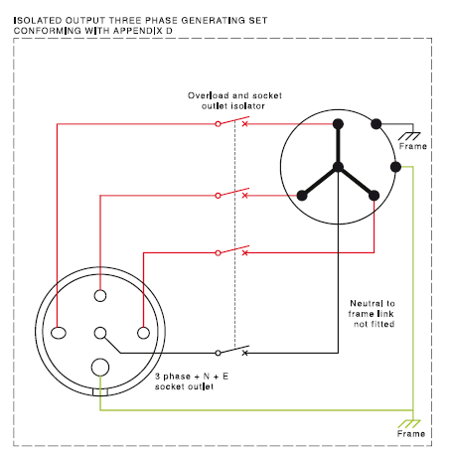
Figure 2: AS 3010:2017 Figure B2 Three phase generating set with 3 phase +N+E connection
- Three phase (RCD Protected)

There shall be connection made between frame and winding neutral.

Where 3 phase +N connection or single phase outlets are available on a three phase generator, the outlets shall be protected by RCDs or suitable earth leakage protection device where the input terminal of the RCD/ELD shall be connected to the earth terminal of generating frame. EL protection shall be 30mA pickup if load is directly connected to the generator; Otherwise, 100mA ELD may be used to obtain discrimination provided the most immediate ELD for each load set for 30mA pick up.

Outlets and cord extensions
The outlets must be rated for desired application as per section 5.2.1. They must have relevant RCD protection and overload protection as per sections 5.2.2.4 or 5.2.2.5
Overload protection and RCD device should be capable of breaking all phases including the neutral.
Single phase outlets: Must be 3 pin flat type as per AS 3112 in 10A or 15A rated outlets.
Single phase or multi-phase where generating set is over 2.5kW shall be in accordance of AS 3123 round pin when supply is greater than 15A. The model and design of outlet shall suit the application of the generator as per Section 5.2.1.
Heavy duty cords may be used as extension where they are rated adequately for the generator supply.
Earth connection from each outlet shall be connected to the generator common equipotential bonding system.

Batteries
Effort should be made to obtain an AGM or VRLA type 12V batteries. The condition of the batteries should be good with no leakages, hissing noises or signs of swelling or obvious damage. The battery compartment shall be readily accessible for replacement or jump starting.

Performance- General

Rating
The output rating of the generator should match with its load application. At the time of the installation, it should be inspected whether loading capacity is exceeded, or type of load characteristics including inductive/capacitive nature, number of phases, voltage or frequency is unsuitable for the generator and vise-versa.

Speed governance (>15kW)
Generators with load capacity higher than 15kW should have speed governance capability. Refer OEM technical specification to verify that speed governance parameters meet requirements of table below.
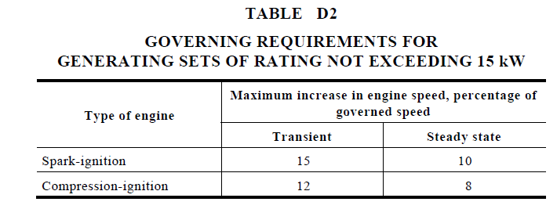
Table 1: AS 3010:2017 Table D2 Speed governance requirement

Non-emergency shutdown facilities
The local control panel shall provide appropriate shutdown protection. The control panel shall be easily accessible, and ‘how to operate’ instructions must be included in the Operator Instructions Manual. The shutdown facility shall operate independent of speed governor. It should have the capability to initiate an immediate shutdown. This may be achieved by either cutoff air intake or shutoff fuel solenoid.
For generators that can supply over 15kW shall have automatic shutdown facilities for:
- Low lubricating-oil pressure
- High coolant temperature (Defined by OEM)
- An overspeed of 25% against rated rpm

Voltage regulation
The generator output shall regulate voltage within $±$5% of rated voltage in steady stage conditions between no-load and rated load. A test shall be done in no-loaded condition to verify that output voltage meets this requirement.

Mechanical protection

Design and construction
The generating set shall be constructed as a singular unit where all parts including the fuel tank, radiators or any associated auxiliary devices shall be common mounted. The generator shall be able to be transported or lifted as a whole set.

Access and location of components
The design shall allow provisions for parts that require routine maintenance to be readily accessible without the need of major dismantling.
Components of the generator such as rotating devices, fuel tank or the exhaust system shall be built in a way it allows reasonable access for routine maintenance whilst avoiding any hazardous situations. Any hazardous item or part that may be accessed during maintenance shall be provided with adequate provisions for positive isolation as per section 5.2.5.1.

Temperature management and thermal safety
At any given moment surface temperature of any part of the generator shall not exceed 100ºC. Generators that have output exceeding 15kW shall conform to section 5.2.3.3 Shutdown facilities for overheating.

Protection against moving parts
All moving parts that may pose a risk to personnel shall be enclosed by appropriate guarding to prevent inadvertent contact. Further, provision shall be given to external rotating parts such as a flywheel to ensure they do not disintegrate during runaway condition.

Fuel management and safety. Fuel system, cooling system, lubricating oil
The fuel piping and tank shall be compatible with the type of fuel used. Galvanized steel shall not be in contact with diesel fuel. Consideration shall be given to ensure fuel does not spill over onto hot or rotating parts even if tank is overfilled.

Exhaust
Arrangement of exhaust shall be in such a manner that it does not cause a hazard to nearby personnel or render it difficult to access generator control panel or emergency push button(s). Exhaust fumes shall be directed away from the fuel supply system and other heat sensitive elements such as electrical wiring. Extra precaution must be taken to ensure there will be no accumulation of exhaust fumes, especially in indoor or confined space arrangements.

Safety

Isolation-Generator
The generator shall be provided with means for effective isolation that will prevent cranking, starting, and running of the generator set. The isolation device shall be an integrated part of the generator set, clearly marked as ‘Starter Isolation’ or ‘Generator Isolation’
A separate battery isolator may be provided that is clearly marked ‘Battery Isolator’
All isolation devices shall have provision to be locked in off position by a personal danger lock.
For generators that feed a switchboard or uses fixed wiring (where supply is not limited to pin outlets), there shall be an electrical isolation device that can be locked out in the isolated position. In all other cases there shall provision for quick effective isolation method that will provide a visual break and shall provide a minimum of IP2X protection against inadvertent contact to potential live parts. i.e. generator that has only plugged outlets.

Emergency shutdown and cut-off
The generator shall have the means for an emergency shutdown when required. The emergency shutdown must be fail-safe in nature and shall be activated by the means of a pressing a button. The push button shall be readily accessible to personal and should be clearly marked as ‘Emergency Stop’. The button shall be latched once activated and shall require deliberate intervention to be reset.
If the emergency push button has been activated, it shall prevent cranking, starting and running of the generator.
Where air break CBs are fitted for outgoing circuits, activation of the emergency pushbutton shall trip primary bus feeder to all outgoing circuits as minimum.

Fire Safety
Appropriate fire safety measures must be taken. Location of installation should be free of material that may combust or prolong the duration of a fire.
As a minimum one 9kg AB(E) dry chemical powder type Fire Extinguisher must be available within 5m of the installation. The fire extinguisher shall be tested every 6 months and pressure levels maintained. The fire fighting equipment must be clearly marked with appropriate signage.

Signage and markings
The generator shall have a permanently installed and legibly marked nameplate that contains the following information.
- Name of the manufacturer
- Model number
- Engine/alternator serial number
- Type of fuel
- Rated output in watts/kilowatts
- Rated voltage and frequency
- IP classification of enclosure (where applicable)
The frame must have a clearly marked earthing symbol or labelled ‘Frame’ earthing connection point.
If the generator is intended for undercover usage only, it shall be marked ‘NOT WEATHERPROOF’
A warning sign shall indicate requirement of a licensed electrical personnel for installation as such:
WARNING
THE OUTPUT OF THIS GENERATING SET IS POTENTIALLY
LETHAL. THE SET SHALL NOT BE CONNECTED TO A FIXED ELECTRICAL
INSTALLATION BY FIXED WIRING EXCEPT BY AN APPROPRIATELY
LICENSED PERSON. SEE INSTRUCTION MANUAL.
All LV electrical enclosures or guarded/covered live parts must be marked with appropriate voltage and isolation requirement signs. i.e.
WARNING
240VAC
Isolate elsewhere
Each outlet shall be clearly marked with its respective voltage. All cable leads or output cables must be legibly marked with cable numbers as referred to in the generator’s technical manual.
Patrol driven engines shall be marked as below in a suitable location so an operator would notice during re-fuel.
WARNING
DO NOT REFUEL WHILE ENGINE IS RUNNING

Other general use signage in similar wording (If not stated in the instructions manual):
- DO NOT OPERATE IN A HAZARDOUS LOCATION, E.G. WHERE THERE MAY BE A RISK OF EXPLOSION OF PETROL FUMES, LEAKING GAS OR EXPLOSIVE DUSTS
- DO NOT OPERATE IN A CONFINED AREA WHERE EXHAUST GASES, SMOKE OR FUMES COULD REACH DANGEROUS CONCENTRATIONS
Any other required signs such as
- Noise Warning (If noise level exceeds 85dB in normal operating conditions)
- Fuel tank
- Pinch points
- Hot surfaces
- Fire extinguisher

Documentation
The owner of the equipment must provide a technical manual, an operator’s instructions manual and updated technical drawings (including site electrical installation where applicable). A copy of these documents must be provided to Field Maintenance Department. Another copy shall be stored appropriately (free from dust, water and sun damage) with the generator set.
The instructions manual must provide:
- Any warnings or safety precautions for starting, normal operation and shut down of generator set.
- Step by step instructions for operation of the generator include starting, running and shutdown.
- OEM contact or support line details.

Post installation and commissioning
After all tests and installation requirements has been completed to satisfactory, the specification checklist form must be handed over to EEM for final approval and obtain authority to energize. After which a maintenance scheme will be set for routine inspection and service. The maintenance requirements are beyond the scope of this specification and therefore shall meet OEM requirements and site regular generator set maintenance scheme.

